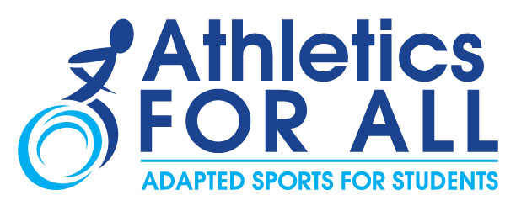

March 2017

To the Members of the National Federation of State High School Associations,

FREE ADAPTIVE SPORTS EDUCATION OPPORTUNITIES FOR HIGH SCHOOL STAFF

On behalf of the Athletics for All Task Force you are invited to volunteer at upcoming Adaptive Sports USA Regional Events. These regional competition events are open to all school professionals involved in or wanting to learn more about adaptive sports. The events provide a venue for a hands-on immersion experience for coaches and teachers in adaptive sports such as track and field, swimming, boccia, goalball, and more! It is also an opportunity to share best practices and current trends in the school inclusion movement. The volunteer immersion opportunities go hand in hand with the mission of the Athletics for All Task Force which is to inform and provide the tools and guidelines by which coaches, athletic directors and school administrators can include students with a physical disability in interscholastic sports.

If you are interested in learning more about the events or registering to volunteer for a specific event, click here!

In addition, we’re pleased to offer you series of FREE webinars! Upcoming webinars will include the topics and sports listed below. Please click on the respective webinar links to register.
- School Athletics & Inclusion: April 27th, 4-4:45pm EDT
Learn about interscholastic sports programs for students with disabilities and how you can integrate athletes into sports like track & field, swimming, and more! Featuring panelists from California Interscholastic Federation, Special Olympics, U.S. Paralympics, and Disabled Sports USA.
- Sports Specific Webinar Training Series:
Learn how to integrate athletes with disabilities into the various sports within your school’s interscholastic program or how to start an inclusive team sport. Learn about introductory training & equipment, competition & rules, safety and injury prevention for ambulatory, wheelchair, or visually impaired athletes!
  - Field events: April 11th, 4-5pm EDT. Featuring coaches from U.S. Paralympics Track & Field
  - Track events: May 4th, 4-5pm EDT. Featuring coaches from U.S. Paralympics Track & Field
  - Goalball: May 18th, 5-6pm EDT. Featuring coaches from United States Association for Blind Athletes
  - Swimming: July 13th, 5-6pm EDT. Featuring coaches from U.S. Paralympics Swimming

We hope you join us at one of the events and/or webinars and look forward to being a resource for you moving forward. If you have questions, please contact us via email at hgomezgarcia@dsusa.org or 240-268-0864.

Sincerely,

Huayra Gomez-Garcia
Athletics for All Task Force Manager

